Step 1:
Open your Project:
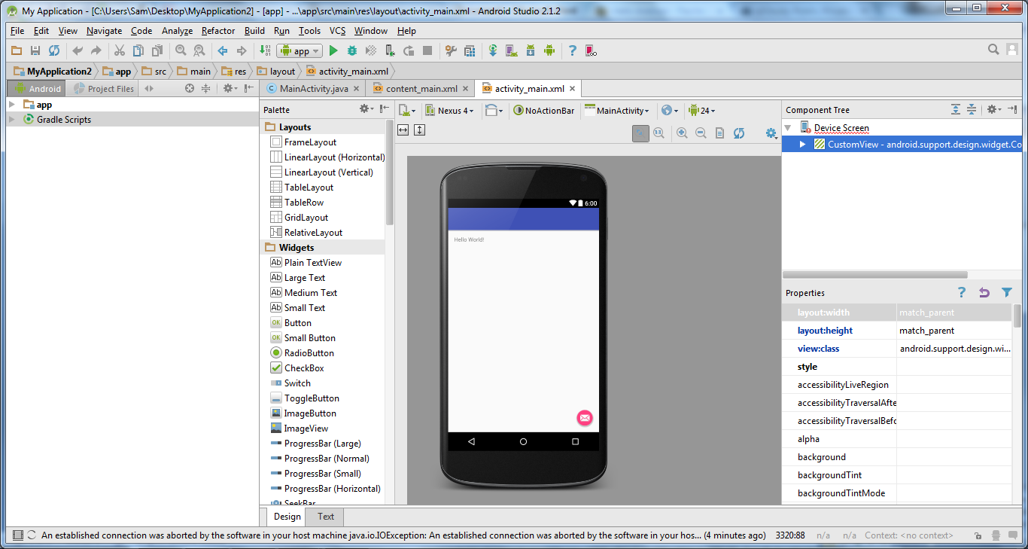

Step 2:
Open your android real device(Mobile) and click on the about phone:
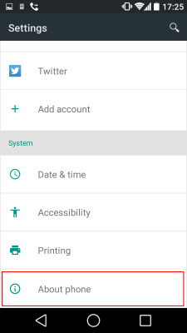

Step 3:
Tap 7 times the build number in the android real device:
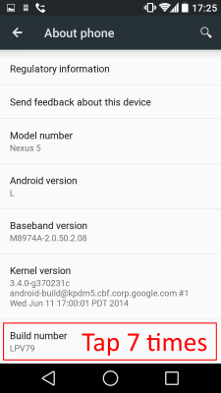

Step 4:
Then go back to settings you will see "Developer Options" menu. After that Android will tell that "You are Developer",
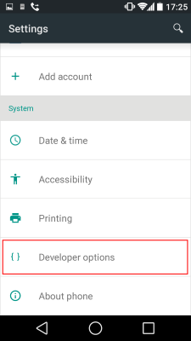

Step 5:
In the Developer option screen check "USB Debugging" as the picture below
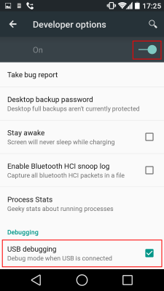

Step 6:

Install ADB USB Driver from the SDK Manager:

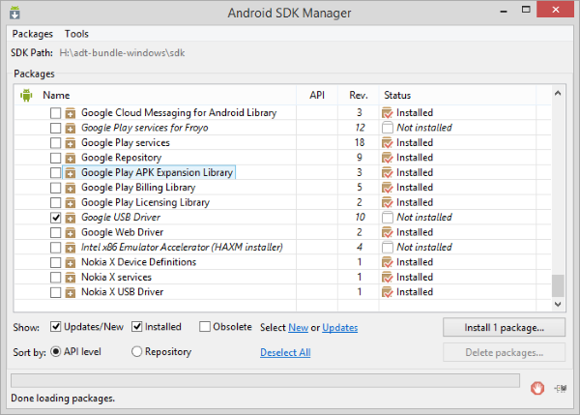
Then click "Install <number> packages..." button.
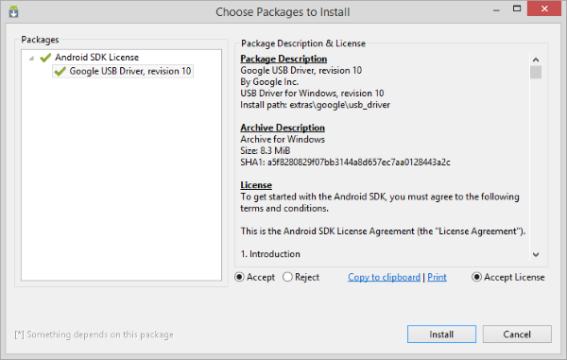
Then Update the device manager from the control panel: 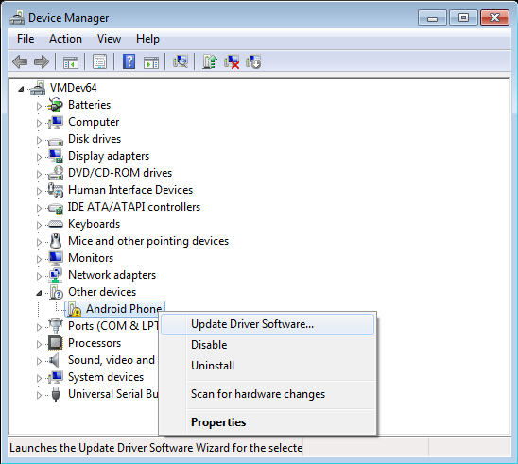
Browse in the computer for driver software
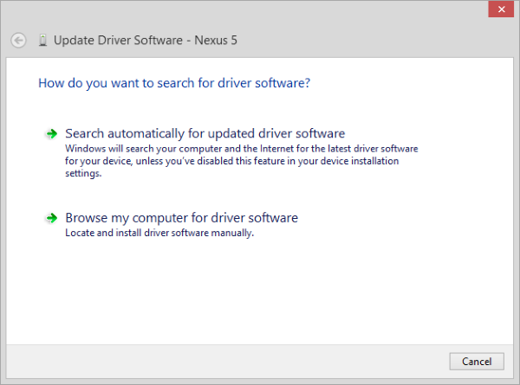
Select from the hard disk:

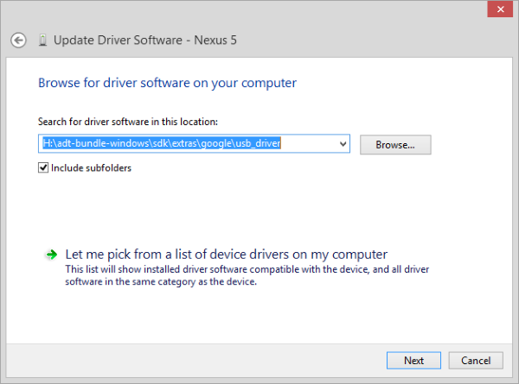

Mobile device is updated:

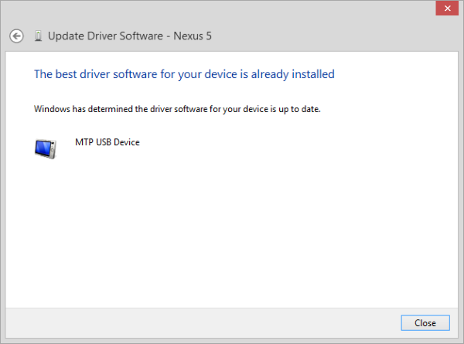
Step 7:
Then deploy your device:
Deploy your application to Device:
To deploy the application to Android Device the method is as same as deploy an application to Emulator but when "Choose Device" window shown, select your device instread Emulator.
Click the "Run 'app'" (Green Triangle) on the toolbar (or shortcut Shift + F10 on Windows OS):
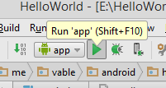

Step 8:
Then the "Choose Device" window will show.
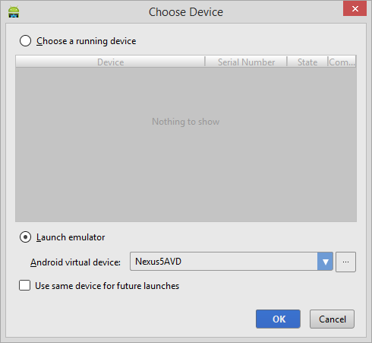

Step 9:
App can be run in the android real device:
